AI based solid waste detection

# Meet Kevadiya

*School of Computer Science University of Windsor* Windsor, Canada

SID: 110092731

# Hamza Baig

*School of Computer Science University of Windsor* Windsor, Canada

SID: 110089314

# Arjun Kheni

*School of Computer Science University of Windsor* Windsor, Canada

SID: 110094003

# Himani Rabari

*School of Computer Science University of Windsor* Windsor, Canada

SID: 110091002

***Abstract*—The urgent issue of trash accumulation facing the planet calls for quick attention. In order to address this problem, there is a need for creative solutions because the current waste management systems are insufficient. In this study, we used the cutting-edge object detection algorithm YOLOv5 to create a trash item recognition model and integrated it with a mobile application. The smartphone application offers a platform for users to recycle trash and engage in gamified competition with their peers. The model will identify the item’s type and provide details on how to recycle it when users scan the rubbish using the app. Users of the app can earn awards for recycling more rubbish. The method is intended to encourage individuals to recycle and minimize waste.**

ACKNOWLEDGEMENT

We would like to thank Dr. Shafaq Khan for all the guidance she provided us throughout the semester. Additionally, we give acknowledgment to the developers of PyTorch, Yolov5, and Google Colab.

1. INTRODUCTION

Effective management of solid waste is crucial for promoting sustainable development and preventing adverse health and environmental impacts. However, the traditional method of sorting and categorizing waste is a tedious and time- consuming task that often leads to errors, inconsistencies, and inefficiencies. To address these challenges, Artificial Intelligence (AI) can be leveraged to automate waste classification. By employing computer vision techniques like image processing and machine learning algorithms, AI-based solid waste classification systems can accurately classify different types of waste such as plastics, metals, paper, and organic waste. Furthermore, an android application can be developed to enhance the user experience.

1. PROBLEM STATEMENT
2. *Problem Description and Formulation*

Population bursts and the industrial revolution have resulted in a significant rise in the generation of solid waste. According to the world bank, 2.01 billion tons of Municipal Solid Waste are generated globally every year and it’s further projected to increase to 3.40 billion tons by 2050 [1]. Accounting for this, the traditional hand-pick method for waste classification is no longer efficient in terms of time as well as accuracy. Furthermore, the former method also consists of the risk that

a person sorting the waste can be infected with a disease. The Global Covid-19 pandemic had created further difficulties in manual waste disposal systems.

Moreover, the development of an AI-based waste classification system also faces several challenges. One of the major challenges is the complexity and variability of waste materials which makes it difficult for an AI model to accurately classify the waste. To overcome the issue, there is a need to develop an efficient AI model that can accurately classify solid waste based on its nature.

1. *Motivation*

The world is currently facing a pressing issue in waste management due to the rapidly increasing amount of waste being generated. A significant challenge in this field is the accurate and efficient classification of waste to ensure proper disposal and recycling. Conventional methods for waste classification are often laborious, time-consuming, and prone to errors, resulting in inefficiencies and environmental harm. There are different strategies followed by various counties to solve the issue of waste management. For example, [2] Japan has an efficient waste management system with a ”3R” strategy, encouraging individuals to sort their garbage into distinct categories. Germany has a “closed-loop” waste management strategy with over 70% of garbage recycled or composted. [2] Sweden has a unique waste management system where practically all trash is burnt to create power and heat in waste- to-energy plants, and the government aims to be fossil-fuel- free by 2040. Singapore has a strict waste management system, requiring citizens to dispose of their waste in designated bins, and providing incentives such as cash rewards and tax breaks for recycling. The United States’ waste management differs by state and municipality, with some having curbside recycling programs and “pay as you toss” systems, but there is still a significant amount of garbage ending up in landfills and a growing push for more sustainable waste management practices.

The application of AI-based waste classification can bring a revolutionary change in waste management by utilizing machine learning to achieve precise and efficient classification. By automating the process of waste classification, we can enhance the effectiveness and accuracy of waste management and reduce the negative impact of waste on the environment and public health. The success of this project can represent a major

milestone toward creating a sustainable and efficient waste management system and can inspire other similar initiatives to tackle the global waste crisis.

1. LITERATURE REVIEW

S. Cheema et. al [3] propose a system that classifies the waste into bio and non-bio waste using cameras, Raspberry Pi, and deep learning algorithms. An Image of a single waste material is faded to the system which through the help of IOT and deep learning predicts the category most suitable for that waste product.

Fig. 1. Comparison between different techniques

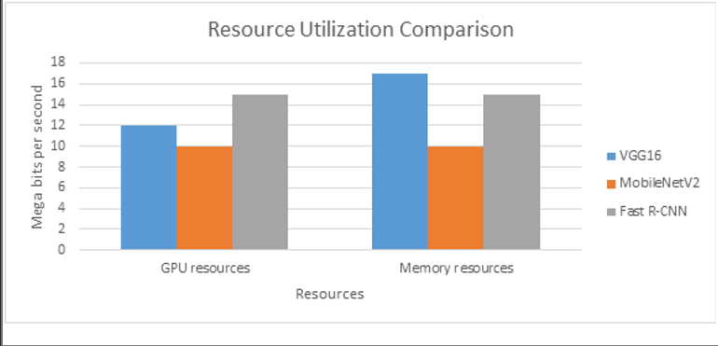

The second research paper, I. Ihsanullah et. al [4] are more focused on the prediction of waste generation rather than classification. It uses multiple ML techniques such as SVM, Neural Networks, and KNN to improve the accuracy of the algorithm. The paper also proposes methods to handle the increased amount of waste.

O. Adedeji et. al [5] is closely related to what we are planning to work on in this project. The paper uses ResNet-50 along with CNN to predict and categorize the waste product based on the image. To improve efficiency, a dropout layer is added along with ResNet-50 and CNN.

M. K. Hasan et. al [6] discuss a new type of garbage bin that is connected to the internet and can communicate with a central database. The bin uses an ultrasonic sensor to measure the amount of garbage in it, and a microchip processes this information and sends it to the internet. The bin also has a load size sensor that can measure the weight of the garbage collected. The system is controlled by an ESP8266 node MCU microcontroller and can be further improved by adding other measuring devices.

In the last paper, Srivatsan K. et. al [7] performs a comparison of 8 different models with different configurations and datasets to measure which model gives the best accuracy. The authors proposed transfer learning with data augmentation for 3 models; ResNet34, DenseNet121, and MobileNetV2, and compared the accuracy of their configurations with the same models without the new configurations. The authors are not taking into account what materials are recyclable or organic. Overall, everyone is classifying waste based on image classification. These models give desired output while working on an image containing a single waste product. However, in real life,

waste can be one or more items of different categories such as plastic, rubber, food, etc. This scenario is not handled by any of the above research papers. Moreover, the real implication should also provide a platform like an application where users can use this Machine learning model. According to the United States Environmental Protection Agency (EPA), about 25% of the waste generated in the US is mixed and not separated into specific categories for recycling or composting.

1. METHODOLOGY
2. *Material and Data*

[8] The dataset was used to train yolov5 for detecting solid waste from images. 91% of the data is taken as training data, and the rest was used for testing and validation. This work was done with the following libraries:

* + pytorch 1.10.1+cuda113
  + Yolov5
  + Google Collab
  + Flutter
  + Android Studio

1. *Proposed Method*

Yolov5 is a family of lightweight deep convolutional neural network architectures designed for detecting multiple objects in a video or image with only one attempt.

The model will be trained to learn different types of wastes provided in the dataset. The reason for using Yolov5 is due to its high accuracy, which was evident in the literature review, and the reason that it utilizes fewer resources which makes it best suited for a mobile application.

Fig. 2. [10] Yolov5 architecture

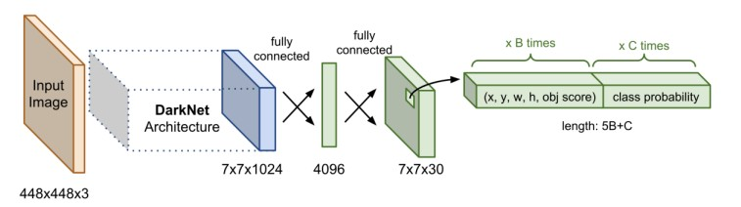

We are proposing a mobile application built on flutter. The mobile application will let users scan waste, it would identify the type of waste whether the waste is organic, recyclable, or paper, and would guide the user by letting them know which bin to throw the waste in. The application will use the concept of gamification, which would be there to trigger the dopamine effect. The users will have the option to add friends, create a group, and check their points in the application.

The points are gained by recycling garbage. The more the user recycles garbage, the more points he/she will have. The user will scan waste that he/she is not sure of and will use the application to throw the waste into the correct bin, the application will detect whether the waste is recyclable or not and will inform the user to throw the waste into its respective bin, this whole activity will give the user a point, encouraging them to use the app more often and compete with their friends,

making the process of recycling fun and rewarding. For the identification of waste, a model (Yolov5) trained on the dataset will be used.

1. *Drawbacks of base papers*

The papers we read only discussed the possibility of creating a waste classifier and were only classifying single waste items from images. The papers did not discuss practical use cases for such a classifier.

1. *Improvements over base papers*

All the research papers we reviewed did only classification and did not detect multiple objects in an image. We are proposing an application that will detect multiple waste objects. The application will grow awareness and contribute towards proper segregation and recycling of waste by helping users identify waste and by providing awareness.

We are not just classifying waste materials into different classes, but also, we’re proposing an application that would spread awareness for recycling. The concept of gamification will make people feel rewarded for recycling, and they will compete with each other to remain on top of the leaderboard. We have trained Yolov5 for classifying waste into different categories and developed a mobile application that uses the classifier. The mobile application is built using flutter and firebase was used as data storage(database).

1. FUNCTIONAL REQUIREMENTS

The Waste Classification app will have several functional requirements.

1. User authentication: Users will need to sign in or create an account in order to access the app, with options to sign in using email/password or through their Google account.
2. Waste Classification: The app will allow users to take photos of waste materials or use the live camera feature to identify multiple types of waste using machine learning.
3. Information on waste management: Information on proper waste management techniques such as recycling, composting, and landfilling will also be provided to users. The app will display data on the amount of waste thrown out and the percentage of recyclable and non-recyclable waste, available directly on the user’s dashboard.
4. Notifications: Users will receive notifications for upcoming trash pickup schedules and other waste management news, and they will be able to check waste collection schedules based on their postal code directly in the app.
5. Localization: The app will support multiple languages and regions, including French, English, and others.
6. EXPERIMENTS

We have trained Yolov5 with 50 epochs, a batch size of 16, and the optimizer was set as Adam.

91% of the data set was used as the training set. Yolov5

was run with multiple configurations and we received the best results with the above configurations.

1. *Evaluation metrics*

The evaluation metrics used were training loss and validation loss. The graphs highlight that the results are good, especially for the training loss where the loss gradually goes down. The validation loss on the other hand did lower gradually but it displayed some fluctuations.

1. *Results and Analysis*

The model gives a decent performance, with the given amount of data, if the data is increased and the quality of the dataset is improved, the model will perform subsequently better.

Fig. 3. Training Loss

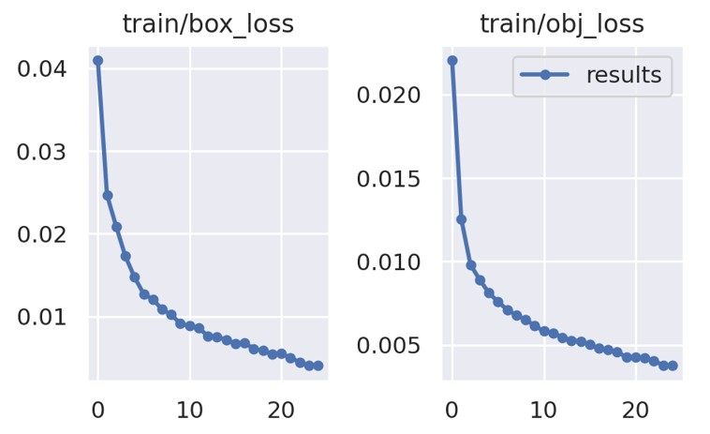

Fig. 4. Validation Loss

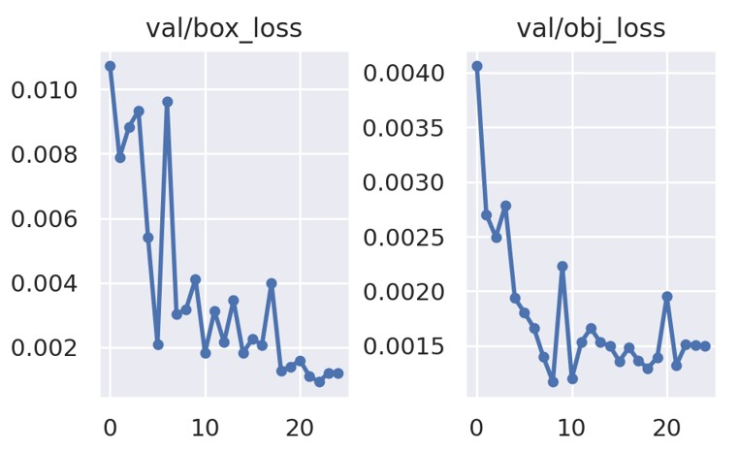

The above graphs highlight that the dataset is training too well, which shows signs of a bit of overfitting. The model will perform better with a better dataset, as the dataset we used had already been increased by using data augmentation and it still is a small-sized dataset with only 2000 images.

1. *Limitations*

We have developed a mobile application and due to a lack of experience, we have not integrated it with the detector yet. The model is performing well but it struggles under some conditions, which is a problem to be addressed in future research.

Fig. 5. Sample Output1

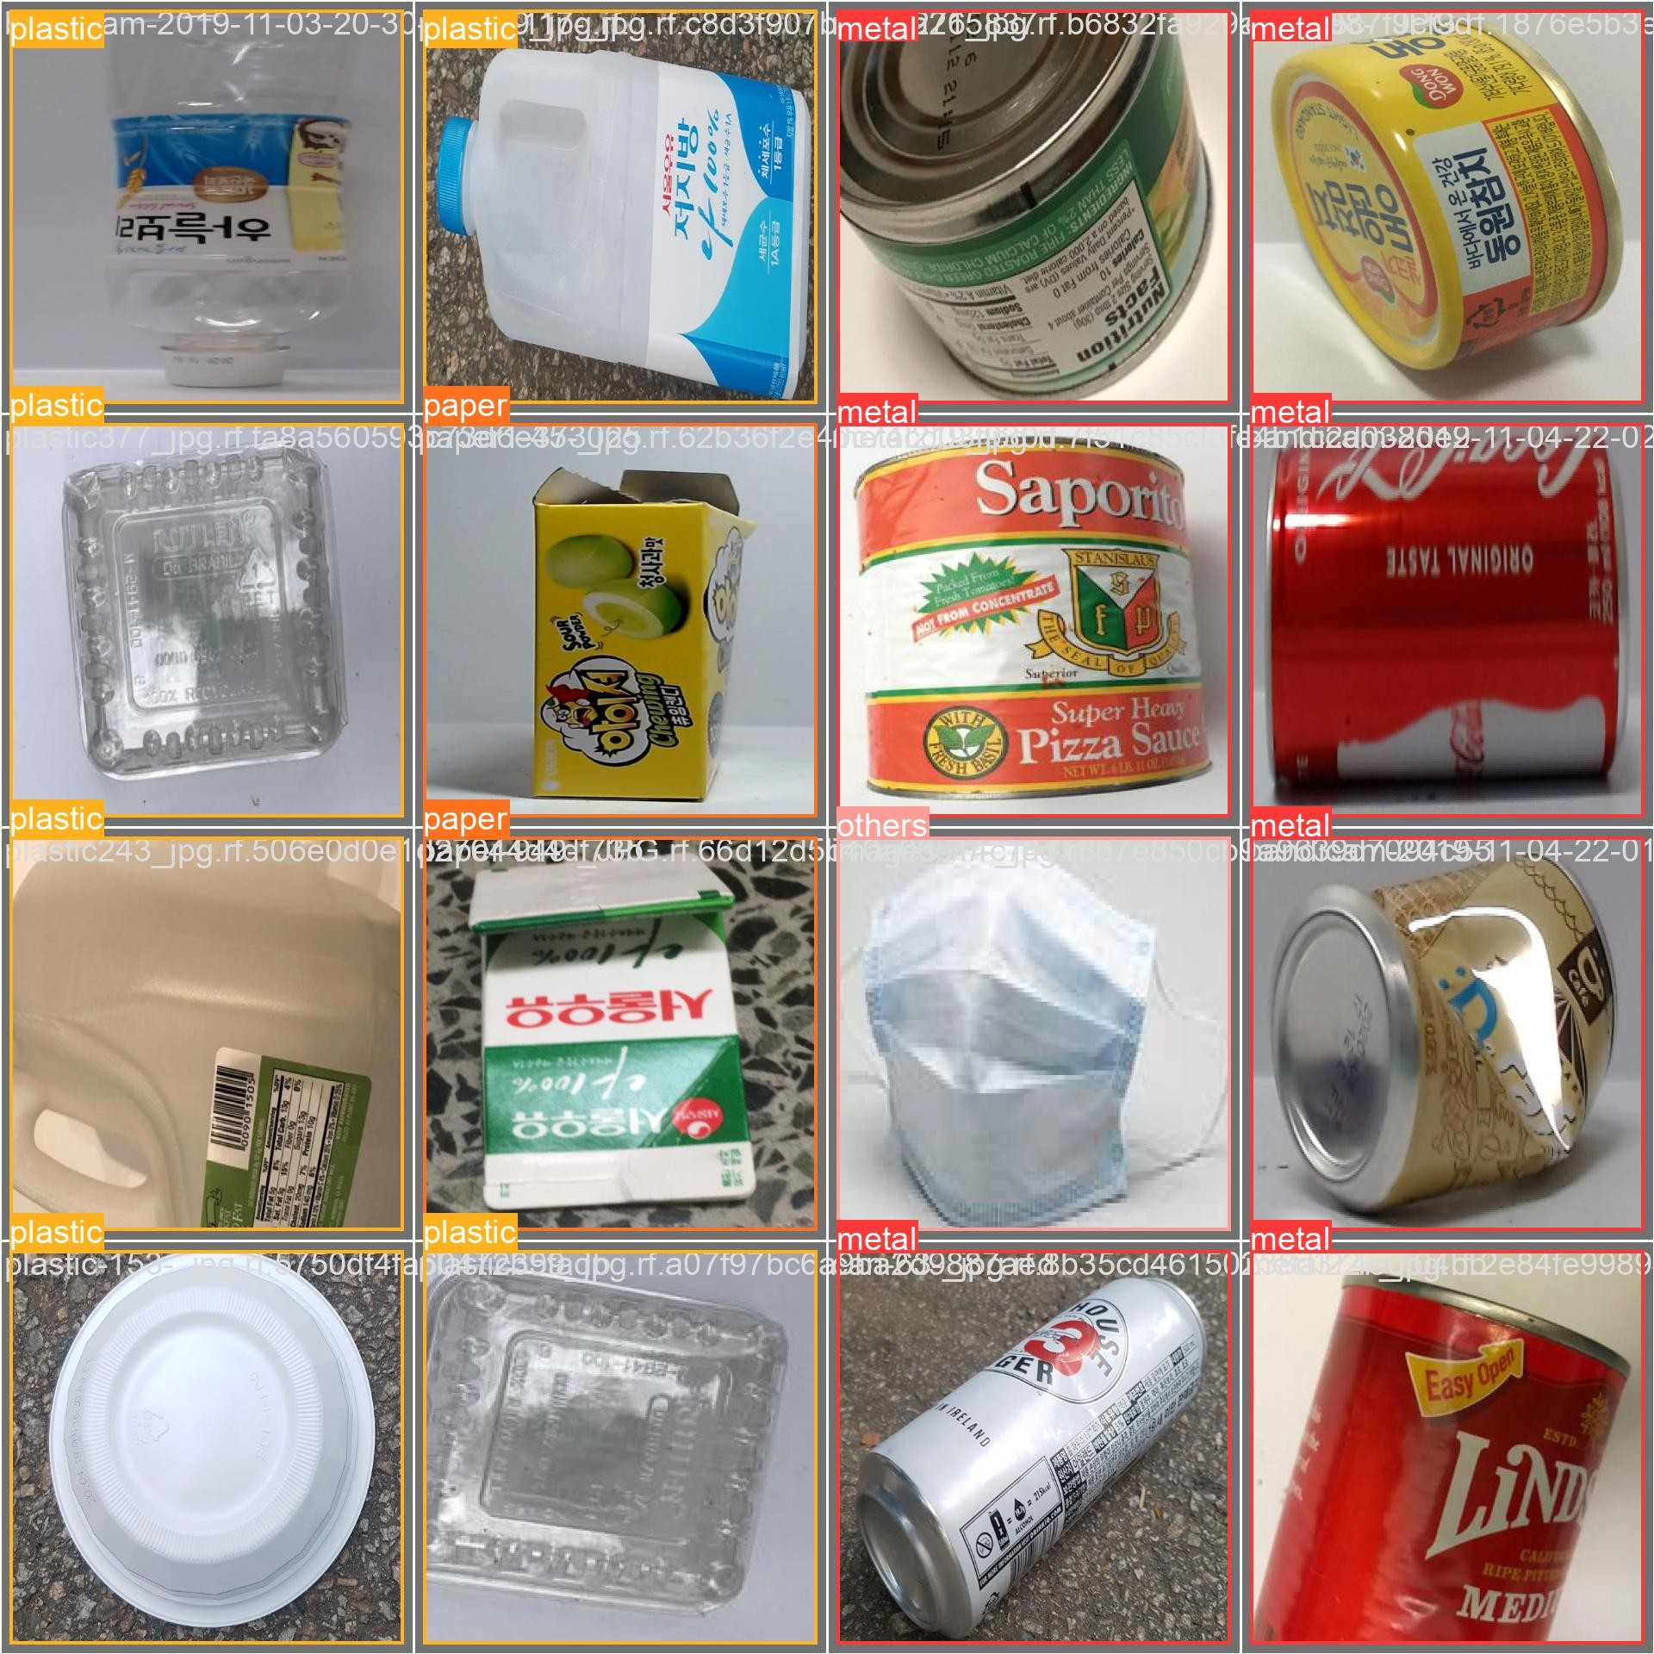

Fig. 6. Sample Output2

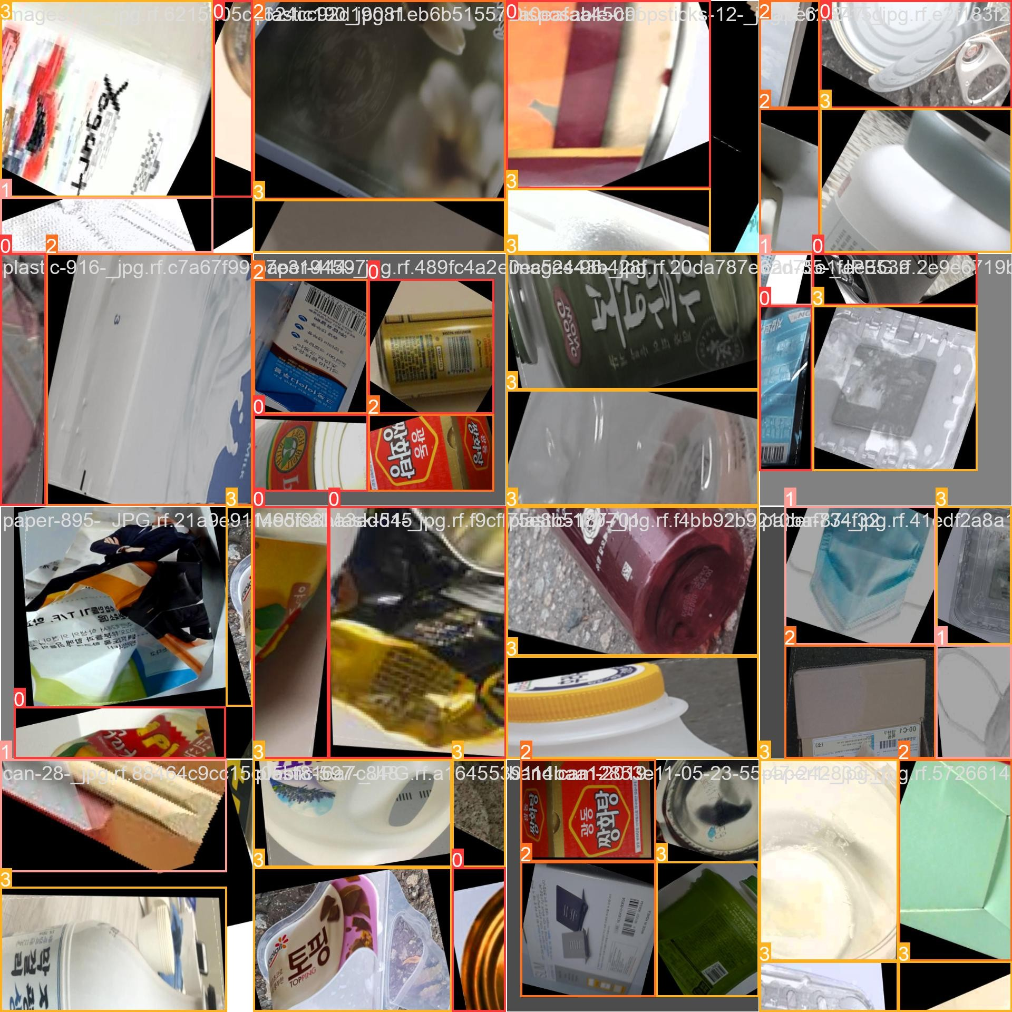

The model is struggling to detect multiple waste items in a single frame, and is giving low accuracy for the classifications, this is a problem due to the dataset selected, as the dataset is not adequate to train a model with high accuracy.

1. CONCLUSION
2. *Summary*

We read a lot of research papers that used different types of techniques for classifying waste material. We have proposed the use of Yolov5 for real-time classification and detection of solid waste in images and videos. We have also developed a mobile application interface for using the detector. We have introduced gamification to encourage people to recycle more and feel rewarded for it, as they’ll get points for recycling more. The results can be improved more.

1. *Future Work*

We can improve the performance of our model by improving the quality of the dataset. To improve the dataset, we can

use techniques such as data augmentation where we can use multiple techniques such as flipping, cropping, and many more.

The mobile application will be integrated with the detector and will include features such as add friends, competing with them, getting digital gifts that can be bought through digital points, receive notifications for waste pickup times, and classify waste to throw into the correct bin. All of this will spread awareness and will work towards a better cause.

1. *Open Problems*

Although the model has achieved decent results, it is still to be put to test against other state-of-the-art techniques for a better understanding of the performance of the model. The model requires a lot of improvements, it performs well under some conditions, especially when the number of items in an image is small, but struggles to perform well as the number of objects increases. The model can be improved to perform better on images that contain multiple objects and the accuracy of the model can be improved as well.

REFERENCES

1. What a waste 2.0 Trends in Solid Waste Management. The World Bank. Available at: https://datatopics.worldbank.org/what-a- waste/trends in solid waste management.html (Accessed: February 15, 2023).
2. OpenMind BBVA’s knowledge community Estimated reading time Time 3 to read et al. (2020) 5 recycling lessons from different countries in the world, OpenMind. Available at: [https://www](http://www.bbvaopenmind.com/en/science/environment/5-recycling-).bbv[aopenmind.com/en/science/environment/5-recycling-](http://www.bbvaopenmind.com/en/science/environment/5-recycling-) lessons-from-different-countries-in-the-world/ (Accessed: February 27, 2023).
3. Smart Waste Management and classification system for smart cities using cutting edge approach. Available at:

[https://www.researchgate.net/publication/360230167](http://www.researchgate.net/publication/360230167) Smart Waste Management and (Accessed: February 28, 2023).

[4]I. Ihsanullah, G. Alam, A. Jamal, and F. Shaik, “Recent advances in applications of artificial intelligence in solid waste management: A Review,” Chemosphere, vol. 309, p. 136631, 2022.

[5]O. Adedeji and Z. Wang, “Intelligent Waste Classification system using deep learning convolutional neural network,” Procedia Manufacturing, vol. 35, pp. 607–612, 2019.

[6]M. K. Hasan, M. A. Khan, G. F. Issa, A. Atta, A. S. Akram, and M. Hassan, “Smart Waste Management and classification system for Smart Cities using deep learning,” 2022 International Conference on Business Analytics for Technology and Security (ICBATS), 2022.

1. Srivatsan, K., Dhiman, S., & Jain, A. (2021). Waste Classification using Transfer Learning with Convolutional Neural Networks. IOP Conference Series: Earth and Environmental Science, 775(1), 012010. https://doi.org/10.1088/1755-1315/775/1/012010.
2. https://universe.roboflow.com/yolov5-aympo/waste-detection- 1zarq/dataset/2

[9] A. G. Howard et al., ”MobileNets: Efficient Convolutional Neural Networks for Mobile Vision Applications,” arXiv:1704.04861, 2017.

[10] D. Thuan, “Evolution of yolo algorithm and Yolov5: The state-of-the-art object detention algorithm,” Theseus, 01-Jan-1970. [Online]. Available: [https://www.theseus.fi/handle/10024/452552.](http://www.theseus.fi/handle/10024/452552) [Accessed: 28-Mar-2023].